USER GUIDE

UPDATE Patient types

September 2018

Version 1.02

Pharmacon ITC303/309 Group

Document Revisions

|  |  |  |
| --- | --- | --- |
| Date | Version Number | Document Changes |
| 31/08/2018 | 1.01 | Draft |
| 15/09/2018 | 1.02 | Initial |
|  |  |  |
|  |  |  |
|  |  |  |
|  |  |  |
|  |  |  |
|  |  |  |
|  |  |  |

Table of Contents

1 Introduction 4

1.1 Scope and Purpose 4

1.2 Process Overview 4

2 Update Patient Types 5

2.1 Update Patient Type 5

2.1.1 To Update an Patient Type: 5

# Introduction

## Scope and Purpose

The purpose of this user guide is to provide instructions on how to update an error type that has already been entered and requires correction.

No other features of the Pharmacy Error Tracker (PET) application will be discussed in this user guide.

* To be able to use PET, the user will need basic knowledge of logging into an online application and using a search function to locate records.
* To be able to search Patient Types within PET.
* This feature is only available to a user with administrator rights.

## Process Overview

The administrator will need to log into PET using their valid username and password.

* The Welcome Page will be presented on successful login.
* The administrator will need to select Search Patient Types via the menu bar or the button on the menu page.
* The user is to enter a search criterion.

# Update Patient Types

User must have located the required record via Search Patient Types.

## Update Patient Type

User must have access to the application.

User must have a valid username and password with administration rights.

### To Update a Patient Type:

1. To update details of the patient type, select the record by clicking on the to the right of the record.

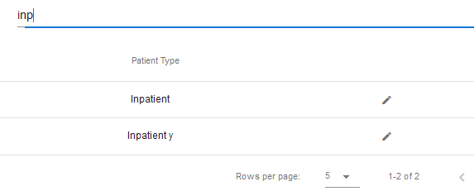

1. The selected record will load into the Patient Type Details form, providing full patient type information

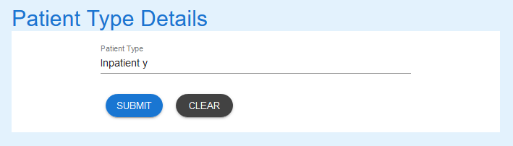

1. Amend the record as required.

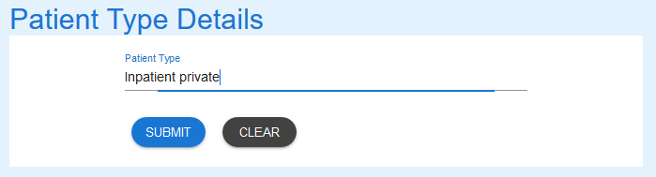

1. Select the “Submit” button to update the record in the database. A message stating record has been updated successfully is returned.

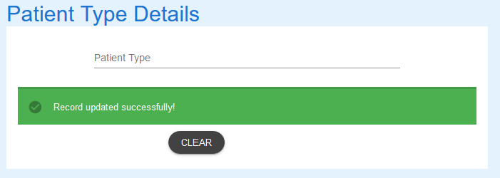

1. A search for “priv” shows the record has been updated

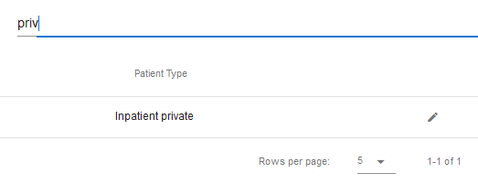

If you encounter issues not addressed by this user guide, please contact your account manager for additional support.